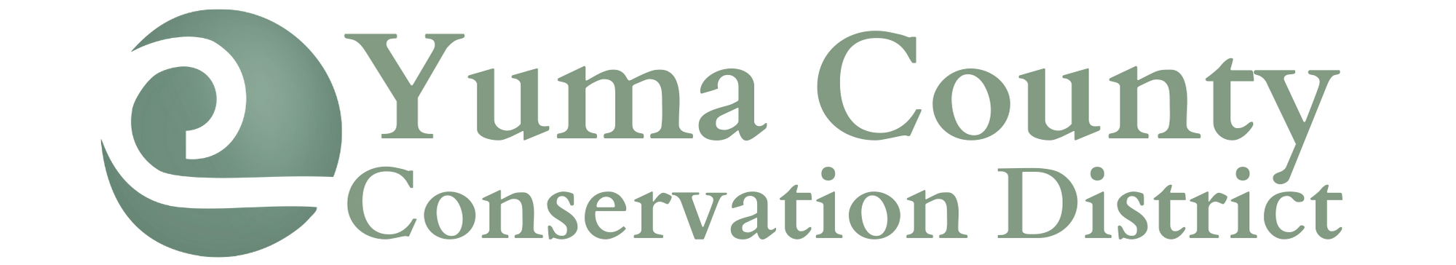
247 N Clay Street ● Wray, CO 80758 ● 970-332-3107 ext. 101

BOARD OF DIRECTORS MEETING MINUTES
April 18, 2022

A meeting of the Yuma County Conservation District was called to order by President Margaret Lenz at 8:30am at the Fish Hatchery.
Those attending included: Margaret Lenz, Ron Richards, Dustin Wise, Travis Taylor, Jeff Wingfield and Tanya Fell.
Updates were made by each board member to the mileage calendar.
Dustin moved to approve the March 8, 2022, meeting minutes, Ron seconded the motion. Motion passed.
Tanya Fell presented the financials. Dustin moved to accept the financial report and pay the April bills, Ron seconded the motion. Motion passed. The current bills paid:
- District Manager Paycheck
- Visa
- Refunds for Bulk Tree Discounts
- Trees & Supplies
- CACD Dues
Ron made a motion for Tanya is to contact Premier Accounting to contract for quarterly withholdings and tax reports, Dustin seconded the motion. Motion passed.
OLD BUSINESS:
Trees were delivered today and pickups are set for Friday and Saturday 4/22 and 4/23. There are multiple nurseries that have trees shipping today and should arrive by Thursday. The Wray, Idalia and Liberty FFA chapters have students who will be helping. It was discussed that several people are wanting to use the planting equipment, but it is fairly difficult to operate and is damaged. The board is considering purchasing new equipment this next year.
Travis gave a report on the watershed meeting that was held March 24th in Cheyenne Wells.
The CACD is offering a $10,000 demonstration grant. The YCCD is going to work on getting approval to do a grazing project to help restore the riparian area at Bonny Dam. Ron made a motion to move forward with writing a grant proposal, Dustin seconded the motion. Motion passed.
The YCCD will also work on a grant proposal for the CSCB Matching Grant program for 2023. The grant will be similar to the one that YCCD had in 2021 for assisting with well drilling, pipelines, and solar pumps. A motion was made by Dusting to move forward with writing the grant proposal, Jeff seconded the motion. Motion passed.
The YCCD drought funding Drip Line project applications were reviewed. It was discussed to allow a Christmas tree farm to participate as well. Dustin made a motion to include the Christmas tree farm, Jeff seconded the motion. Motion passed. In addition, the board decided to fund all the applicants for funding. Dustin made a motion to approve all applications submitted, Jeff seconded the motion. Motion passed.
Currently there have been no scholarship applications. The deadline will be extended through May 5th. Tanya is to talk to Elizabeth Riggleman and also the ag teachers.
There were 22 individuals that participated in the pesticide applicator workshop.

NEW BUSINESS:
Travis discussed the conference call regarding the Wildlife Federation and the project that they are seeking grant funding for. The board would like to set a conference call with them to discuss the options further. Travis will get a conference call set.
An executive session was held but no decisions were made.
Dustin made a motion to adjourn the meeting and Ron seconded the motion. Motion passed.
The next YCCD meeting will be held May 10th at 5:30pm at the NRCS conference room.

Respectfully Submitted,

Tanya Fell
District Manager
Yuma County Conservation District

