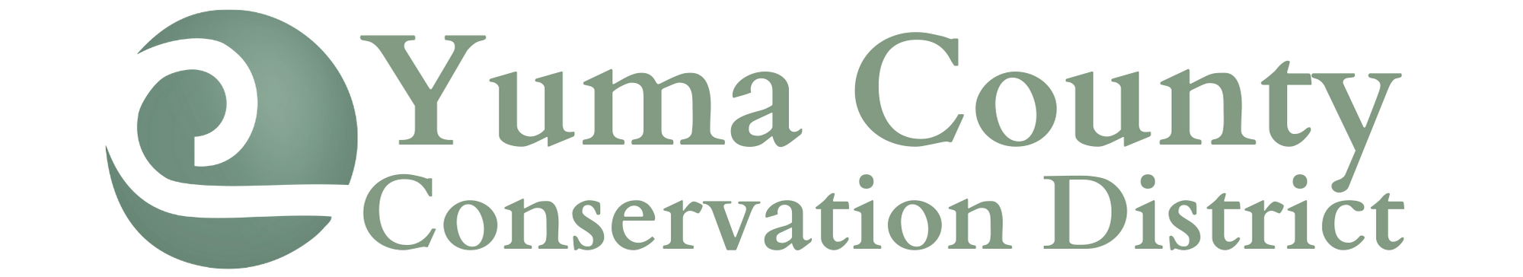
247 N Clay Street ● Wray, CO 80758 ● 970-332-3107 ext. 101

BOARD OF DIRECTORS MEETING MINUTES
MARCH 8, 2022

A meeting of the Yuma County Conservation District was called to order by President Margaret Lenz at 10:02am at the Wray Town Hall meeting room.
Those attending included: Margaret Lenz, Ron Richards, Dustin Wise, Jeff Wingfield, Travis Taylor, Kaci Porter and Tanya Fell.
Updates were made by each board member to the mileage calendar.
Dustin moved to approve the February 8, 2022, meeting minutes, Jeff seconded the motion. Motion passed.
Tanya Fell presented the financials. Dustin moved to accept the financial report and pay the February/March bills, Jeff seconded the motion. Motion passed. The current bills paid:
- District Manager Paycheck
- Visa
Kyle Hendrix is to bring his final payment this week for his tree balance. He has a balance of $332.97 remaining.
OLD BUSINESS:
The past meeting minutes have been added to the YCCD website in the Board of Directors section.
Tanya reported that trees are selling well.
The matching grant final report was submitted with the necessary adjustments. Additional checks may be issued to those who spent over $4500 in matching funds.
Farming Evolution was held February 16 and 17th. Ron reported that there were a number of good speakers. Some ideas for 2023 topics are water, hot to transition from full to partial irrigation.
Margaret reported that the watershed meeting will be held March 24th at 9:30am in Cheyenne Wells. Topics to be discussed include the Good and Bad of Wind Farms, Carbon Credit Market and others. Tanya is to RSVP for Margaret, Jake, Tanya (in-person) and Dustin, Ron and Jeff (via Zoom).
Kaci from the Yuma Conservation District attended our meeting.
- She reported that the YCD tree sales are down this year.
- They YCD is planning to use their drought funding for an Ag Innovators Symposium on September. They will focus on soil health and have speakers travel to do the workshop.
- YCD is participating in the Matching Grant program again this year for a windbreak tree program.
- YCD is also planning to do a three day youth camp during the summer.
So far they YCCD has received two windbreak drought funding applications.
The YCCD Memorial Scholarship was re-created and turned into a fillable application. The scholarship application was sent to all YCCD ag teachers, science teachers and school counselors.
The Workgroup Survey draft is complete. The board wanted other added to what sector the person completing the form is from.
Upcoming workshops were discussed.
- Pesticide Applicator Workshop – The workshop is set for March 16th at the Wray Roundhouse. Sandra McDonald will be the certifier and educator.
- The Rejuvra workshop will be facilitated by Derek Sebastian with Bayer. Perspective dates are April 20 or 21. There are some area plots as well that producers will be able to visit. The workshop will begin at 9 with presentations followed by a field tour.
- The Wray Dam tour is still in process. Once we receive the state engineers report we will determine a tour date and time. One idea is to hold the tour the day that the trees arrive.
- A Farm and Ranch Hunting and Trespassing Workshop will be discussed with Josh Melby and Wilbur Strick. It is thought to hold the workshop in mid to late June. Some potential speakers include Sarah Wages Johnson an attorney, Scott Limmer with Comanche Outfitters or Bo Davis.
- Huck Finn Days in June working in conjunction with the Wray Museum.
There were no additional nominations for the YCCD board of directors, so a motion was made to cancel the election by Jeff. The motion was seconded by Dusting and the motion passed. Tanya is to find out who can give the Oath of Office from Nikki.

NEW BUSINESS:
The District Manager, Tanya Fell, will have her contract changed from salary to hourly to maintain compliance with Colorado Employment Laws. The hourly wage will be $20 per hour. Jeff will review and adjust the employment contract. This new wage will be retroactive beginning March 1, 2022. The changes were discussed with Tanya and then a motion to accept was made by Dustin and seconded by Ron. The motion carried.
Jolynn was contacted regarding YCCD supporting the area beekeepers. The support will be discussed at the upcoming beekeepers meeting.
YCCD will participate in the Yuma County Ag Week. Tanya will have handouts available and offer our support for the various events. In addition, board members are invited to attend the presentations regarding water in Wray and Kirk.
Tanya will work on a matching grant proposal for 2023. She is to ask Abby for different project ideas.
A motion was made by Ron to dispense with the executive session and seconded by Dustin. Motion passed.
Dustin made a motion to adjourn the meeting and Ron seconded the motion. Motion passed.
The next YCCD meeting will be held when the trees are unloaded in April.

Respectfully Submitted,

Tanya Fell
District Manager
Yuma County Conservation District

