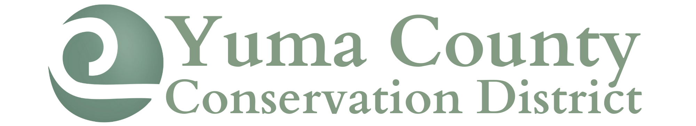
247 N Clay Street ● Wray, CO 80758 ● 970-332-3107 ext. 101

BOARD OF DIRECTORS MEETING MINUTES
May 10, 2022

A meeting of the Yuma County Conservation District was called to order by President Margaret Lenz at 5:36pm at the NRCS conference room in Wray.
Those attending included: Margaret Lenz, Chester Zwirn, Jeff Wingfield and Tanya Fell.
Updates were made by each board member to the mileage calendar.
Jeff moved to approve the April 18, 2022, meeting minutes with one correction, Chester seconded the motion. Motion passed.
Tanya Fell presented the financials. Jeff moved to accept the financial report and pay the May bills, Chester seconded the motion. Motion passed. The current bills paid:
- District Manager Paycheck
- Visa
- Trees & Irrigation Supplies
Jeff will check on rates as CD come due prior to them being rolled into the next term to see if we are able to lock in better rates.
OLD BUSINESS:
Tree distribution went well. Lots of learning for the FFA helpers and Tanya. We will work on having the invoice and sales receipts formatted the same to make sure that the correct number of trees are distributed. It was also determined that a board member needs to double check each order after the FFA pull them prior to loading. The board appreciated all the help from both the Wray and Liberty FFA chapters. A motion was made by Chester to donate $1500 to the Wray FFA chapter and $300 to the Liberty FFA chapter for the help with tree distribution.
The board discussed purchasing new tree planter and landscape fabric laying equipment. The equipment would be made available for rent through the YCCD office. Tanya is to check with Jenny in Burlington to find out the landscape fabric laying machine that they have purchased. It was recommended that we look at Wittman Forestry Company for the tree planting equipment. Tanya will also investigate pricing of both pieces of equipment.
The CACD $10,000 demonstration grant is due May 15th. YCCD board members are the review the completed applications and offer any additions or corrections that they feel are necessary.
Tanya will be working on the 2023 matching grant for the CSCB. YCCD would like to focus on drilling wells, laying pipeline, updating tanks and solar well pumps.
The Wildlife Federation grant is focusing on climate change. They would like for work with producers that are currently raising feed and operating their own feedlots. There is a possibility that the YCCD will partner with them for project oversite and support. More will be determined based on if the grant receives funding.
There were three scholarship applications. The board members reviewed the applications (Margaret abstained to review due to a family member in consideration). Jeff made a motion to award scholarships for both Brady Midcap and Jaden Dodsworth. The motion was seconded by Chester. Motion carried.
NEW BUSINESS:
A motion was made by Chester to dispense with an executive session. Jeff seconded the motion. Motion passed.
Jeff made a motion to adjourn the meeting and Chester seconded the motion. Motion passed.
The next YCCD meeting will be held June 14th at 5:30pm at the NRCS conference room.

Respectfully Submitted,

Tanya Fell
District Manager
Yuma County Conservation District

